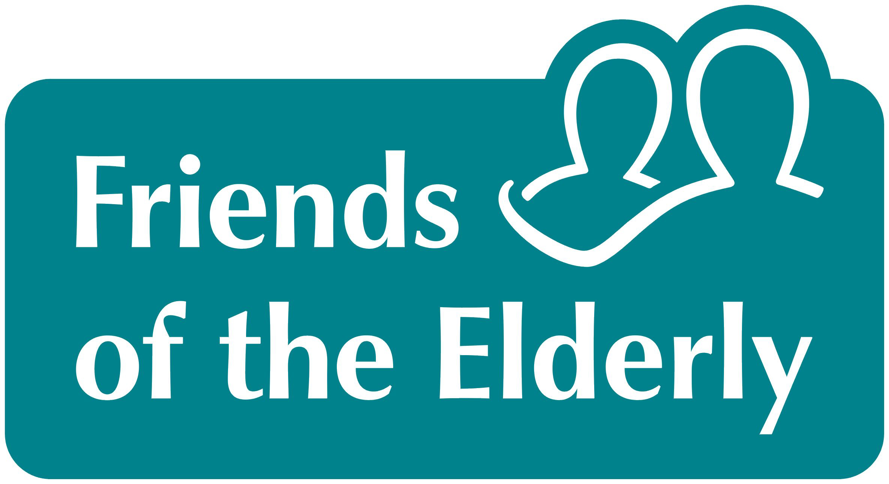
Volunteer Application Form

“Friends of the Elderly value all its volunteers for their part in enhancing the lives of older people, which in turn contributes to changing the society in which we live.”

Section 1

Are you applying for a specific role? If so please state it here and include it in the subject line if you email us:
Date:

How did you hear about Volunteering for Friends of the Elderly?
Friends of the Elderly website |  | Word of mouth
Search for volunteering opportunities on internet |  | Relative known to the service
www.do.it.org.uk website |  | Newspaper advertisement
Volunteer Centre |  | Other (please state)

Personal details
Title: (please tick) | Mr Mrs Miss Ms Other
Gender:
Date of birth: | Please provide if you are under 18 only:________________
First name: |  | Surname:
Known as: |  | Email address:

Address:

Postcode: |  | Home tel:
Mobile: |  | Work tel:
Is it okay for us to ring you at work? Yes No

Section 2 – Employment History
Giving your time and talents to a volunteering cause is an amazing offer and can complement your role in the workplace. Friends of the Elderly see it as very important to know where you have worked and the roles you have undertaken throughout your working life. This is to ensure relevant training; volunteer opportunities and diversity of roles are available and to ensure that we fulfil our safeguarding requirements.

Present/most recent employment
Name of employer: |  | Job title:
Date started: |  | Date finished:

Summary of main responsibilities:

Previous employment
Name of employer: |  | Job title:
Date started: |  | Date finished:
Summary of main responsibilities:

Section 3 – Volunteering experience

Experiences in volunteering
Have you been involved with voluntary organisations before? Yes No
If yes, please give details of your present or most recent volunteering roles:
Name of organisation:
From: | To:
Brief description of your role:

Please provide details of any other volunteering roles you have been involved with:

Have you a personal experience of helping an older person you would like to share

Please give your reasons for wanting to volunteer for Friends of the Elderly, and what you are hoping to gain from the experience

Time and talents – the information from the following 3 sections, Time and Talents and preferences, will be used to match you to an older person (as applicable in a 1:1 situation).

Please tick any of the following you have an interest in, talent or experience of:

Digital |  | Sciences
Gardens |  | Sports
Languages |  | Nature
Arts and Culture |  | Animal lover/owner
Literature |  | Current Affairs
TV/Films |  | History
Other (please state)

Time of volunteering – when are you able to volunteer?
 | Sun |  | Mon |  | Tue |  | Wed |  | Thur |  | Fri |  | Sat
 | am | pm | am | pm | am | pm | am | pm | am | pm | am | pm | am | pm
Regular
Ad hoc

Specific preferences – please indicate which of the following you prefer/don’t mind:

Pets yes □ noTi□mS Smoker yes □ no □

Sf volunteering – when are you able to volunteer?

References
Please provide the contact details of two referees who are not relatives or partners. If possible one referee should have some knowledge of your previous paid work/volunteering.
Reference 1 Name: | Job Title:
Address:
Postcode: | Tel:
Email address: | Relationship to you:

Reference 2 Name: | Job Title:
Address:
Postcode: | Tel:
Email Address: | Relationship to you:

Additional information
Please provide any additional information that might support your application, or might aid us in matching you to an older person (if required)

Rehabilitation of Offenders ACT 1974
Due to the type of work (involving contact with vulnerable people) you are required by the Rehabilitation of Offenders Act 1974 to declare all convictions including spent conviction. (Having a conviction will not necessarily prevent you from becoming a volunteer). You will also be subject to a check by the criminal Records Bureau.
Have you ever been convicted of a criminal offence: Yes No
If yes, please give details of conviction(s) and date(s)

Have you ever received a caution (except for driving offences) Yes No
If yes, please give details of caution(s) and date(s)

Only answer if driving a car is part of the volunteering role you are applying for
Do you hold a current driving licence? | Yes No
If yes, have you held a licence for more than 1 year? | Yes No
Have you been convicted of any motor offence(s) resulting in disqualification? | Yes No

Keeping in touch
We would love to keep you up to date with information on the charity, our services and fundraising through periodic communications by post and/or email

Yes, I am happy to receive updates through the post

Yes, I am happy to receive updates by email

Declaration
At Friends of the Elderly we value your support and respect your privacy. The data we gather and hold is managed in accordance with the Data Protection Act (1998). The information in this form will be used for volunteer management purposes, held on a computer database. We will not disclose or share personal information about you with any third party without your consent.
Full details of our data protection policy can be provided upon request.

“I declare that, to the best of my knowledge and belief, the information provided on this form is correct”.

Name: |  | Signature
Date:

Returning your application form
Email: hello@fote.org.uk
Post: Engagement Hub, Friends of the Elderly, 40-42 Ebury Street, London SW1W 0LZ

Thank you for your interest and for taking the time to complete this form. Please refer to the covering letter regarding process and time lines.

